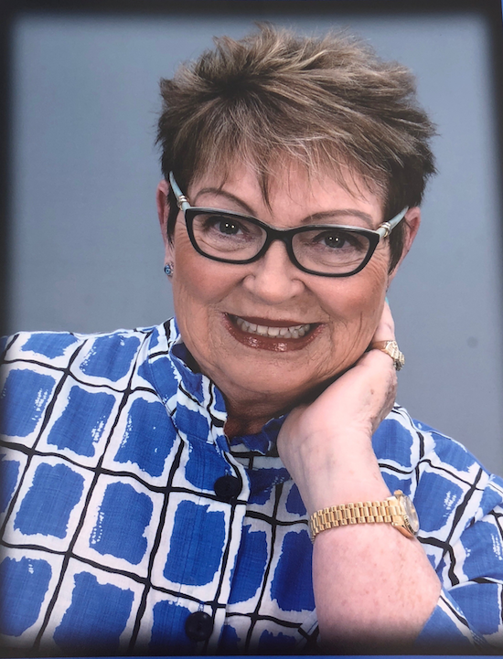
Ann Marie Hancock: Talk Show Host, Investigative Journalist, and…Healer

Ann Marie Hancock is an award-winning journalist, radio personality and talk show host who has interviewed many famous people. Some of her favorites are Alan Alda, Minnie Pearl and Eva Gabor. She has appeared on Bertice Berry, Rolanda, NBC’s The Other Side, The Angel Show, and Inside Edition.
Hancock is the author of two previous books: Be a Light and Wake up America– with which she has traveled the world and shared her message of hope. A devout Christian, Hancock believes that God loves each of us, and offers us healing and peace in any and all of our circumstances through His grace and offer of salvation. Her latest book, “You Can’t Drive Your Car to Your Own Funeral, is a three year journey with her terminal mom, as she shares spiritual and practical tools acquired during this sojourn.

Hancock considers herself blessed and believes in giving back. She has served on the Board of Virginia Wildlife Festival, Goodwill Industries and The James River Association, which ensures the health and reputation of the historic James River. Hancock has received awards from the Virginia Rehabilitation Association, and hosted the first Miss Virginia Wheelchair Pageant. She has also served on the Board of Pediatric Infusion. Hancock is passionate about her four grandchildren, and involved at her former high school alma mater, being named this year “Most Distinguished Alumna” at the renowned Altria Theatre in Virginia. Hancock and her husband have hosted benefits for the Make a Wish Foundation, and they have served as state chair persons for the Catholic Education Concilium.

Ann Marie Hancock lives in Virginia with her husband Tom a retired nationally-recognized health and hospital law attorney who has consistently been listed in Best Lawyers in America.

