Excerpts from You Can’t Drive Your Car to Your Own Funeral

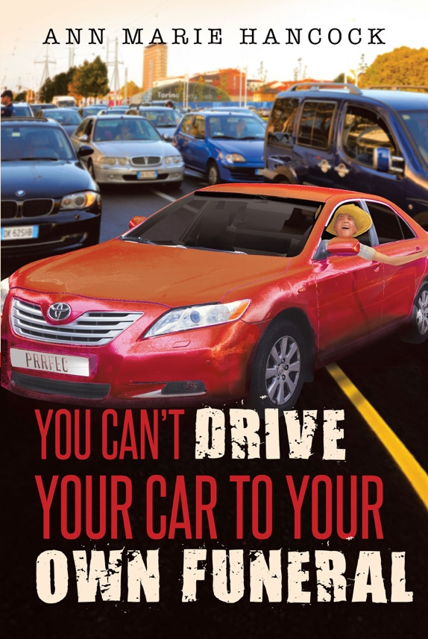
“We all have difficult people in our lives. This creates stress; stress changes the chemical structure of our cells, creating illness and disease.”
“I have often heard it said, God hid all the secrets inside of us…He knew it was the last place we would look.”
“I learned not to take criticism personally…it isn’t easy; we have to dig deeply…go within.”
“Mothers and daughters have a special bond…we are connected by more than an umbilical cord and for a lifetime.”
“Everything is in our computers and it begins in the womb.”
“Unforgiveness binds us.”
“Fear keeps us from our own personal truth…we are loved.”
“Part of love is respect.”
“God can do anything.”
“When God is with you; no one can stand against you.”
“Mom was a determined strong woman…I said, ‘Mom, I think you went through that red light’…she said, ‘Don’t worry about it. Your father did it all the time.’”
“Surely, we have all asked at different times in our lives, ‘Why me?’ No one escapes the treachery of sickness and pain. Anyone present at these times can be a target and claim victim status. But this serves no one. Love requires patience and true confidence which is faith.”
“We do not have to accept negative and destructive messages…We have a choice.”
“Caretaking is an art form, a delicate dance.”
“When we have a profound personal and intimate relationship with God…His grace is so overwhelming that if the whole world stood against you, it would not matter.”
“There can be no joy without forgiveness.”
“Freedom lies in love that releases pain and unforgiveness and allows complete surrender to His thoughts, His Will, His Heart.”
“Negativity originates in fear…I’m not enough so I can’t allow you to be enough.”
“There can be no joy without forgiveness.”
“We are victims of victims.”
“Why does it take crisis or tragedy to think about what really matters?”
“None of us can escape our humanity.”
“God sends angels to encamp when we need them.”
“The sick deserve to be surrounded by helpful, hopeful, loving people.”
“This journey taught me to love more, laugh more…smile at my lessons…I would learn that I can’t fix anybody but me.”
“Stuff provides momentarily joy; Love is forever.”
“The car was mom’s freedom…to her it represented peace and independence.”
“Only Love Heals!”

